AIFDR Infrastructure Design
Client: | 
Document: | AIFDR Infrastructure Design
Abstract: | This document contains IT Infrastructure Design on HPC System, Network, Storage, Clients, Internet, Application services and logical components to support AIFDR operation.
Author: | Widjaja | 
Approval: | Peter Kelly  Ole Nielsen | 
Doc Ref: | 0000.doc
Date: | 20/10/2009

Document Control

Revision | Date | Author | Comments
0.1 (DRAFT) | 30/09/2009 | Widjaja | Initial Draft
1.0 | 09/10/2009 | Widjaja | Revised
1.1 | 11/10/2009 | Ole | Revised
1.2 | 17/10/2009 | Widjaja | Additional IP Public & Email
1.3 | 20/10/2009 | Widjaja | Samba, AD, SID

Contents

1 Introduction 3
1.1 Network Infrastructure 4
1.2 IP Address Allocation 5
1.3 HPC System 6
1.4 Switches 7
1.5 Storage System 8
1.6 Servers 9
1.7 Clients 9
1.8 Operating System 9
1.9 HPC Configuration 10
1.10 Active Directory Configuration 10
1.11 SAMBA Configuration 10
1.12 Security 11
2 Conclusion 13
APPENDIX A – User IDs, Groups and Email 14
APPENDIX B – Telephone System 15

Introduction
The purpose of this document is to detail, at a high level, the architecture associated with the delivery of HPC System, Storage System, Network Infrastructure, Servers, Clients, Internet, and Application services to support and meet AIFDR operation requirements.

The main components that will be covered are:

- Network Infrastructure
- IP Addressing
- HPC System
- Storage System
- Switches
- Servers
- Clients
- Operating System
- Application Configuration
- Security / Firewall

The design document is considered to be a continuing element of AIFDR program which detailed up to operation and maintenance procedure of components on this design document.

Network Infrastructure
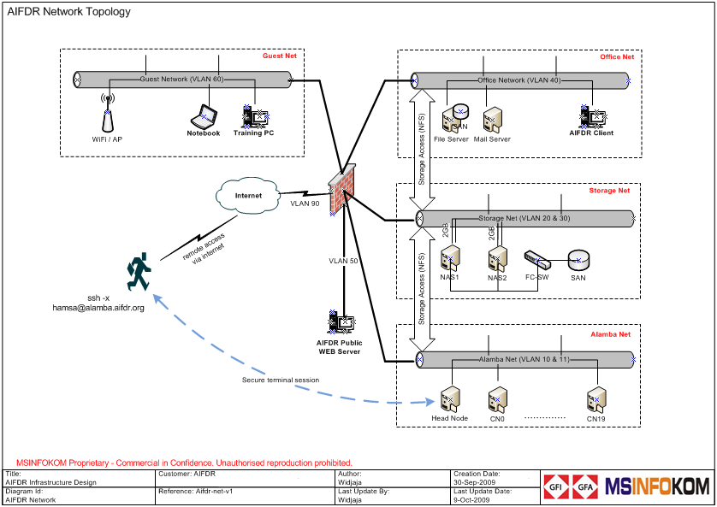

IP Address Allocation
Based on network design, the IP Address allocations are divided by VLAN ID considering functionality, usability, network traffic and security issues. The IP Address Allocation is described as below:

VLAN ID | Description | Used by | IP Allocation
1 | Default VLAN | Not used | -
2 | Mgmt Net | OA & ILO  SAN Switch  Eth Switch  PABX | 192.168.2.10 – 99  192.168.2.100 – 102  192.168.2.200 – 210  192.168.2.200 – 204
10 | Alamba-A Net | Head node  (Used by terminal session from internal / internet) | 192.168.10.10
11 | Alamba-B Net | Head node  Compute node (node1 - 20)  (Used by internal communication between HN-CN only)  PXE (only during boot-up) | 192.168.11.10  192.168.11.11 – 30  192.168.11.60 – 90
20 | Storage-A Net | Virtual IP for NAS  NAS1  NAS2  (Used by internal communication between HN/CN – Storage only) | 192.168.20.10  192.168.20.11  192.168.20.12
30 | Storage-B Net | Virtual IP for NAS  NAS1  NAS2  (Used by communication between Office Network – Storage only) | 192.168.30.10  192.168.30.11  192.168.30.12
40 | Office Net | Mail Server  File Server  Client PC / Notebook (DHCP)  Printers  Etc | 192.168.40.10  192.168.40.11  192.168.40.20 – 199  192.168.40.200 – 210
50 | Web Net | Web Server | 192.168.50.10
60 | Guest Net | Training Room (DHCP)  WiFi (DHCP) | 192.168.60.10  192.168.60.100
90 | Inter Net | Public IP Pool ISP | 202.158.46.176/28

HPC System
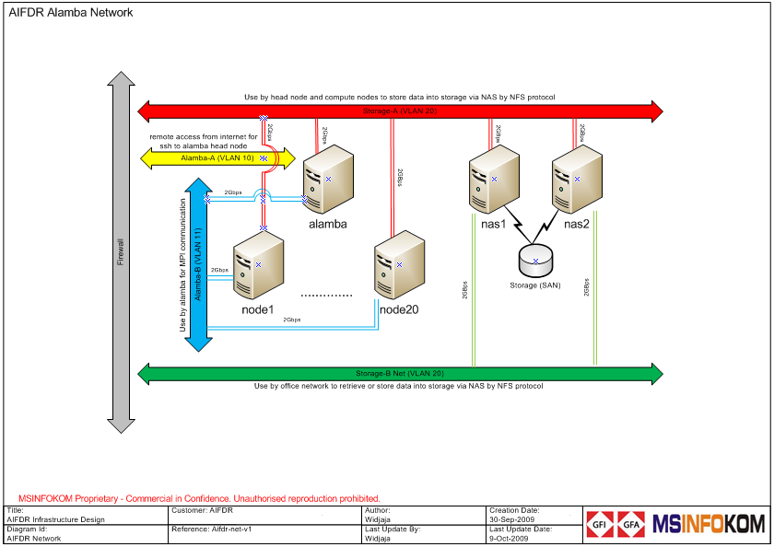
Need more info for HPC

The head node and compute nodes are connected 2Gbps to Layer 3 Alcatel Switch both on alamba network and storage network. This design give maximum performance which each head node and compute node can communicate up to 4Gbps Full Duplex for internal communication and storage access.
(Ole: Did some network timimngs on Saturday that indicate possible problems– need more work on this.)
The IP Address allocation for head-node:

Head node | Eth0 | eth1 | Eth2 | eth3 | eth7
Head node | Bond0 (VLAN 11) |  | Bond1 (VLAN 20) |  | VLAN 10
headnode | 192.168.11.10 |  | 192.168.20.10 |  | 192.168.10.10

The IP Address allocation for compute-nodes:

Compute node | eth0 | eth9 | eth10 | eth11
Compute node | Bond0 (VLAN 11) |  | bond1 (VLAN 20)
node1 | 192.168.11.11 |  | 192.168.20.11
node2 | 192.168.11.12 |  | 192.168.20.12
node3 | 192.168.11.13 |  | 192.168.20.13
node4 | 192.168.11.14 |  | 192.168.20.14
node5 | 192.168.11.15 |  | 192.168.20.15
node6 | 192.168.11.16 |  | 192.168.20.16
node7 | 192.168.11.17 |  | 192.168.20.17
node8 | 192.168.11.18 |  | 192.168.20.18
node9 | 192.168.11.19 |  | 192.168.20.19
node10 | 192.168.11.20 |  | 192.168.20.20
node11 | 192.168.11.21 |  | 192.168.20.21
node12 | 192.168.11.22 |  | 192.168.20.22
node13 | 192.168.11.23 |  | 192.168.20.23
node14 | 192.168.11.24 |  | 192.168.20.24
node15 | 192.168.11.25 |  | 192.168.20.25
node16 | 192.168.11.26 |  | 192.168.20.26
node17 | 192.168.11.27 |  | 192.168.20.27
node18 | 192.168.11.28 |  | 192.168.20.28
node19 | 192.168.11.29 |  | 192.168.20.29
node20 | 192.168.11.30 |  | 192.168.20.30

Switches
The AIFDR network is using L3/L4 Alcatel Switches (6850 Series – 48 Ports). The Alcatel Switch 6850 provides 1Gbps / port with switch throughput up to 92Gbps Full Duplex which give maximum performance both for HPC and network access.

Need to color match with cabling color code later

Mapping port on Switch (VLAN 11)

1 | 3 | 5 | 7 | 9 | 11 | 13 | 15 | 17 | 19 | 21 | 23 | 25 | 27 | 29 | 31 | 33 | 35 | 37 | 39 | 41 | 43 | 45 | 47
2 | 4 | 6 | 8 | 10 | 12 | 14 | 16 | 18 | 20 | 22 | 24 | 26 | 28 | 30 | 32 | 34 | 35 | 38 | 40 | 42 | 44 | 46 | 48
HN | COMPUTE NODE |  |  |  |  |  |  |  |  |  |  |  |  |  |  |  |  |  |  |  |  |  | FW

Mapping port on Switch (VLAN 20)

1 | 3 | 5 | 7 | 9 | 11 | 13 | 15 | 17 | 19 | 21 | 23 | 25 | 27 | 29 | 31 | 33 | 35 | 37 | 39 | 41 | 43 | 45 | 47
2 | 4 | 6 | 8 | 10 | 12 | 14 | 16 | 18 | 20 | 22 | 24 | 26 | 28 | 30 | 32 | 34 | 35 | 38 | 40 | 42 | 44 | 46 | 48
HN | COMPUTE NODE |  |  |  |  |  |  |  |  |  |  |  |  |  |  |  |  |  |  |  | NAS |  | FW

Mapping port on Switch (VLAN 30 & 40)

1 | 3 | 5 | 7 | 9 | 11 | 13 | 15 | 17 | 19 | 21 | 23 | 25 | 27 | 29 | 31 | 33 | 35 | 37 | 39 | 41 | 43 | 45 | 47
2 | 4 | 6 | 8 | 10 | 12 | 14 | 16 | 18 | 20 | 22 | 24 | 26 | 28 | 30 | 32 | 34 | 35 | 38 | 40 | 42 | 44 | 46 | 48
OFFICE |  |  |  |  |  |  |  |  |  |  |  |  |  |  |  |  |  |  |  |  | NAS |  | FW

Storage System
There are 2 types of storage systems on AIFDR project:

- Network Attached Storage (NAS) with Storage Area Network (SAN)

NAS and SAN are mainly used by HPC System and Office network clients to store and retrieve any modeling data as input / output to HPC System. There are 2 NAS unit (nas1 and nas2) for high availability and connected to SAN via 2 units SAN Switches.

- Direct Attached Storage (DAS)

File server is used mainly for back office operation to storing Office file documents. Local storage attached to file server simplified the AIFDR network design and added security on file permission compare than store on NAS.

To avoid bottleneck on storage system, the additional 1GBps NIC added to each subnets on nas server which give total 2GBps full speed connectivity on each subnet or 4GBps both on Storage-A network (HPC <–> NAS) and Storage-B network (NAS <-> Office).

The storage traffic from Office to NAS is also connected at 2GB/s routed directly via Layer 3 Alcatel Switch and not routed via Fortinet Firewall to elimate degradation on speed due to firewall packet inspection

The IP Address allocation for NAS:

NAS Device | eth0 | eth1 | eth2 | eth3
NAS Device | Bond0 (VLAN 30) |  | bond1 (VLAN 20)
Virtual IP | 192.168.30.10 |  | 192.168.20.10
nas1 | 192.168.30.11 |  | 192.168.20.11
nas2 | 192.168.30.12 |  | 192.168.20.12

Servers
In addition to HPC system, there are 3 other types of server on AIFDR environment.

- File Server with Windows Active Directory
Used by office client for AD authentication and storing data / office documents.

- Mail Server
Used by office clients and AIFDR users for messaging and communication

- Web Server
For storing public data on web server presence

Need to mention Revision control? Whats the system used? Wiki?

Clients
The clients mainly are using Microsoft Windows XP / Vista and one Ubuntu Linux desktop. The NFS protocol is also configured on each clients to give access to NAS.

The additional standard software is installed on each clients are:

- Microsoft Office 2007
- Symantec AntiVirus
- Adobe reader
- etc

Operating System
The Operating System used on this AIFDR project is based on the functionality of system / servers. The system are based on Linux OS and Microsoft Windows OS as listed on the table below:

Type of Function | Operating System
Head Node | Ubuntu Desktop 9.04
Compute Node | Ubuntu Desktop 9.04
NAS | RedHat
File Server | Windows 2008
Mail Server | Windows 2008
Backup Server | RedHat
Client | Windows XP  Ubuntu Desktop 9.10

HPC Configuration
The entire installation and configuration process has been scripted to allow for rapid and reliable rebuilding of the cluster. These scripts also provide exact documentation of the
steps taken to build the cluster.

The head node on HPC system is configured using the Ubuntu Desktop 9.04 operating system with DHCP Server and PXE server providing boot image and system for each compute node. During boot-up process, each compute node will get dynamic IP Address (VLAN 11) from DHCP server (head node) and start retrieve PXE image from PXE Server (head node) via TFTP protocol to complete the OS Linux booting.

System files for each compute node are kept on the server and are regularly updated using rsync to ensure that any new software installed on the head node is also available on the compute nodes. A script is available to accomplish the synchronisation as part of the installation suite. This script will also synchronise user identities so new users created on the head node become known to each compute node without manual intervention. The scripts and detailed configuration documentation are available at .....

The head node and each compute node mount the /home directory on the NAS. It is therefor critical that user names and ids are kept identical between head node and NAS. The consideration applies to group names and ids.

Each user will have unique userid for unix login to HPC system and windows login to office system. The User’s Add/Move/Change/Delete and Type of Access will be detailed on Standard Operationg Procedure (SOP) during operational as are the group privileges.

Active Directory Configuration
For Windows environment, AIFDR is using Active Directory which provides directory services (LDAP), authentication services (Kerberos), domain naming and network information service.

The domain name for AIFDR would be aifdr.org same with external domain name registered. For internal naming resolution, The Active Directory will also provide roles as domain name server (DNS) which forwarding to external / ISP DNS (202.158.3.7 and 202.158.3.6)

Since the AIFDR organisation structure is not complex, the OU structure would be on 1 level as standard.

SAMBA Configuration
Samba is used for file sharing between Windows and Linux where Windows XP / Vista client can retrieve or store data on storage server that connected to Linux NAS. Linux NAS will be treated as Windows Server domain and the kerberos authentication will be forwarded to Active Directory as part of single authentication.

The reference for Samba and Active Directory integration can be located on:
http://www.howtoforge.com/samba_active_directory

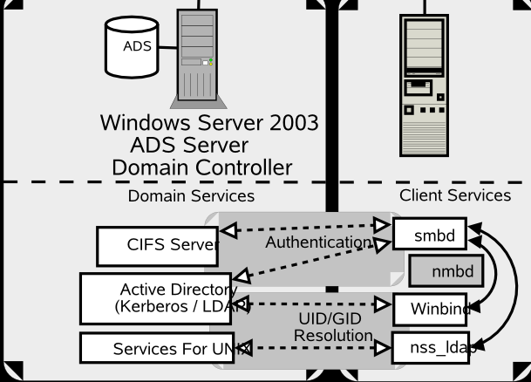

Security
The AIFDR insfrastructure is designed and mind with security concept in build into design, implementation and operation. The security device (firewall) is using Fortigate which is leading Unified Threat Management (UTM) system on security market.

Fortigate 110 is having 8 internal / DMZ ports and 2 external / internet ports, up to 500MB firewall throughput and include with Anti-Virus, Anti-Spam, Web-filtering on ASIC level. The Fortigate firewall will give extra security protection to AIFDR infrastructure.

AIFDR has internet connection thru CBN internet provider which provides 512Kbps dedicated (international) plus 1024Kbps (local loop). IP Address Allocated is 202.158.46.176/28

The switch is connected to FortiGate firewall based on VLAN to the corresponding FortiGate port number:

 | INTERNAL |  |  |  |  |  |  |  | EXTERNAL
Port | 1 | 2 | 3 | 4 | 5 | 6 | 7 | 8 | 1 | 2
VLAN | 2 | 10 | 11 | 20 | 30&40 | 50 | 60 | - | 90 | -
IP | 192.168.2.1 | 192.168.10.1 | 192.168.11.1 | 192.168.20.1 | 192.168.  40.1 | 192.168.50.1 | 192.168.60.1 |  | 202.158.46.178
SM | 255.255.255.0 | 255.255.255.0 | 255.255.255.0 | 255.255.255.0 | 255.255.255.0 | 255.255.255.0 | 255.255.255.0 |  | 255.255.255.240
GW |  |  |  |  |  |  |  |  | 202.158.46.177

The firewall rules will be defined in FortiGate to manage the access control list (ACL) to the AIFDR resources (Headnode, mail server, web server, etc)

Rule# | Source | Destination | Protocol | Direction
1 | Internet | Head Node | SSH | Inbound
2 | Office | Head Node | SSH | Inbound
3 | Guest / Training | Head Node | SSH | Inbound
4 | Head Node | Internet | Any | Outbound
5 | Internet | Mail Server | HTTP / HTTPS | Inbound
6 | Internet | Web Server | HTTP / HTTPS | Inbound
7 | Mail Server | Internet | SMTP | In/Outbound
8 | Mgmt PC | Mgmt VLAN | HTTP / HTTPS / SSH / Telnet | Inbound
9 | Office | Internet | Any | Outbound

The network address translation (NAT) will perform translation from external IP address and map to internal IP address with ACL and packet inspection.

Function | Internal | NAT | External
Head Node | 192.168.10.10 | NAT | 202.158.46.179
Web Server | 192.168.50.10 | NAT | 202.158.46.180
Mail Server | 192.168.40.10 | NAT | 202.158.46.181

HP provides management software for all the blade, servers and peripherals. For this deployment stage, the firewall has configured to allow monitoring, virtual console and virtual power button. The firewall has been NAT for this IP Address and Ports for allow accessing OA and ILO from internet.

Blade Enclosure 1 (OA) with 16 ILO for Blade Server

Inside | Outside | Description
192.168.2.10:443 | 202.158.46.184:8000 | OA
192.168.2.11:443 | 202.158.46.184:8001 | ILO
192.168.2.12:443 | 202.158.46.184:8002 | ILO
192.168.2.13:443 | 202.158.46.184:8003 | ILO
192.168.2.14:443 | 202.158.46.184:8004 | ILO
192.168.2.15:443 | 202.158.46.184:8005 | ILO
192.168.2.16:443 | 202.158.46.184:8006 | ILO
192.168.2.17:443 | 202.158.46.184:8007 | ILO
192.168.2.18:443 | 202.158.46.184:8008 | ILO
192.168.2.19:443 | 202.158.46.184:8009 | ILO
192.168.2.20:443 | 202.158.46.184:8010 | ILO
192.168.2.21:443 | 202.158.46.184:8011 | ILO
192.168.2.22:443 | 202.158.46.184:8012 | ILO
192.168.2.23:443 | 202.158.46.184:8013 | ILO
192.168.2.24:443 | 202.158.46.184:8014 | ILO
192.168.2.25:443 | 202.158.46.184:8015 | ILO
192.168.2.26:443 | 202.158.46.184:8016 | ILO
Blade Enclosure 2 (OA) with 16 ILO for Blade Server

Inside | Outside | Description
192.168.2.27:443 | 202.158.46.184:9000 | OA
192.168.2.28:443 | 202.158.46.184:9001 | ILO
192.168.2.29:443 | 202.158.46.184:9002 | ILO
192.168.2.30:443 | 202.158.46.184:9003 | ILO
192.168.2.31:443 | 202.158.46.184:9004 | ILO
192.168.2.32:443 | 202.158.46.184:9005 | ILO
192.168.2.33:443 | 202.158.46.184:9006 | ILO
192.168.2.34:443 | 202.158.46.184:9007 | ILO
192.168.2.35:443 | 202.158.46.184:9008 | ILO
192.168.2.36:443 | 202.158.46.184:9009 | ILO
192.168.2.37:443 | 202.158.46.184:9010 | ILO
192.168.2.38:443 | 202.158.46.184:9011 | ILO
192.168.2.39:443 | 202.158.46.184:9012 | ILO
192.168.2.40:443 | 202.158.46.184:9013 | ILO
192.168.2.41:443 | 202.158.46.184:9014 | ILO
192.168.2.42:443 | 202.158.46.184:9015 | ILO
192.168.2.43:443 | 202.158.46.184:9016 | ILO

The URL for accessing HP Management software from internet is:

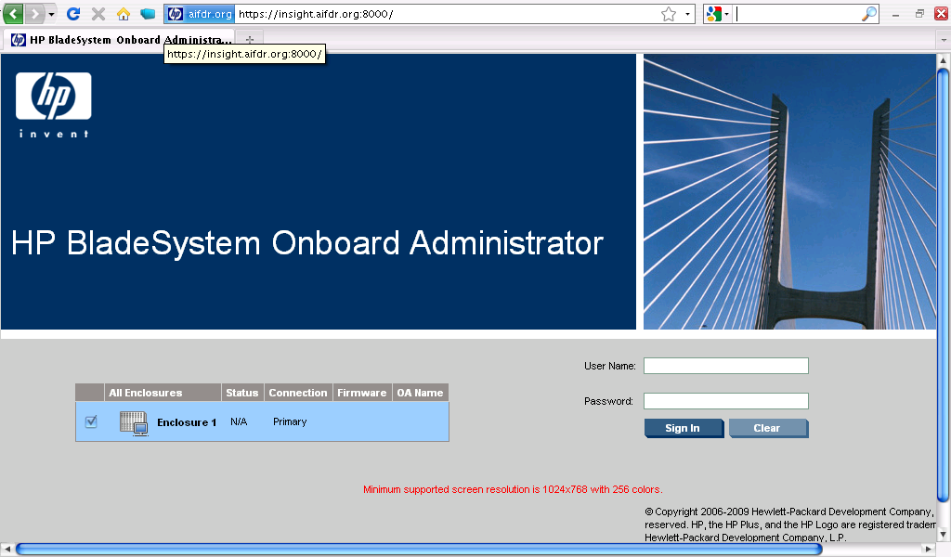

Conclusion

APPENDIX A – User IDs, Groups and Email
Full Name | SID | User Login | Email
Alan March | 1000 | Marcha | alan.march@aifdr.org
Amanda Patrick | 1001 | Patria | amanda.patrick@aifdr.org
Trevor Dhu | 1002 | Dhutre | trevor.dhu@aifdr.org
Jason Brown | 1003 | Brownj | jason.brown@aifdr.org
Kristy van Putten | 1004 | Vanpuk | kristy.vanputten@aifdr.org
Wita Katoppo | 1005 | katopw | wita.katoppo@aifdr.org
Radhietya Hadikusuma | 1006 | Hadikr | radhietya.hadikusuma@aifdr.org
Andre Abednego | 1007 | Abedna | andre.abednego@aifdr.org
Anita Dwyer | 1008 | Dwyera | anita.dwyer@aifdr.org
Ole Nielsen | 1009 | Nielso | ole.nielsen@aifdr.org
Jonathan Griffin | 1010 | Griffj | jonathan.griffin@aifdr.org
 | 1011
Guest1 | 2000 |  | -
Guest2 | 2001 |  | -
Group1 | 800
Group2 | 801

APPENDIX B – Telephone System

IP Address Information for Telephony System

Module | IP Address | Subnet Mask | Default Gateway
Call Server | 192.168.2.250 | 255.255.255.0 | 192.168.2.1
Gateway Driver | 192.168.2.251 | 255.255.255.0 | 192.168.2.1
Voice Mail | 192.168.2.252 | 255.255.255.0 | 192.168.2.1
IP Trunk | 192.168.2.253 | 255.255.255.0 | 192.168.2.1
Installer NB | 192.168.2.254 | 255.255.255.0 | 192.168.2.1

Incoming Line from Telco (Telkom)

Line # | Phone Number | Description
1 | 398 30088 | Default Number (Hunting)
2 | 398 30068 | Default Fax
3 | 398 30049
4 | 398 30065
5 | 398 30067
6 | 398 30173
7 | 398 30174
8 | 398 30175
9 | 398 30176

List of Extension Number

Display Name | Ext | Direct # | Local | Mobile | Interstate | International
Alan March | 1000 |  | √ | √ | √ | √
Bernardus Wijaya | 1001 |  | √ | √ | √ | √
Amanda Patrick | 1002 |  | √ | √ | √ | √
Trevor Dhu | 1003 |  | √ | √ | √ | √
Jason Brown | 1004 |  | √ | √ | √ | √
Kristy van Putten | 1005 |  | √ | √ | √ | √
Anita Dwyer | 1006 |  | √ | √ | √ | √
Ole Nielsen | 1007 |  | √ | √ | √ | √
Jonathan Griffin | 1008 |  | √ | √ | √ | √
Wita Katoppo | 1009 |  | √ | √ | √ | √
Andre Abednego | 1010 |  | √ | √ | √ | √
Radhietya Hadikusuma | 1011 |  | √ | √ | √ | √
Fax Machine |  | 398 30068 | √ | √ | √ | √
Meeting Room 1 | 1060
Meeting Room 2 | 1061
Training Room 1 | 1062
Training Room 2 | 1063
Break-out Area | 1064
Server Room | 1065
Receptionist | 0 | 398 30088
Outgoing Line | 9

